**10Meters Transparent Silicone Tube Flexible Rubber Hose Drink Water Pipe Food Grade Connector ID 0.5mm x 2mm OD**

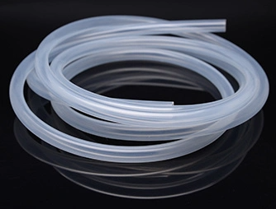

**Specification**

Name: Silicone tube (also known as: silicone tube)

Hardness: 65±5

Tensile strength: ≥6.5

Product color: transparent

Length: 10meters

Temperature resistance range: -60~240℃.

Specification size: 0.5mmx2mm (inner diameter 0.5mm, outer diameter 2mm, wall thickness 0.75mm)

Surface properties: combing water, many materials do not stick, can play a role in isolation of the electrical properties: in the moisture and water or temperature rise, the change is small, even if the short-circuit combustion of silica generated by the insulator, which ensures that the electrical equipment continues to work, so it is suitable for the production of wires, cables, lead wires.

Detection method: available fire will produce, produce white residue.

Appearance: Translucent

Specific gravity(25℃): 1.19

Plasticity: 265

Tensile strength: 7 MPa

Elongation: 325%

Tensile permanent deformation：7%

Tear strength: 20kN/m

GB/T529-1999

Resilience: 50%

Line shrinkage:3%

Volume resistivity: 3.0×10Ω.cm

Breakdown voltage:20kV/mm

**Note: The above data is the result of testing after one molding and vulcanization.**

**Product Features**

①Continuous use temperature range: -60 ~ 240℃

② Soft, arc and corona resistant;

③Can be customized to various specifications according to customers' requirements;

④Harmless, non-toxic and odorless, medical grade;

⑤ High pressure resistance, environmental protection.

**Dimensional drawings**

Inner diameter :0.5mm

Outer diameter :2mm

Wall thickness: 0.75mm

**Tube I.D. X O.D. Diagram**

