## High Torque DC Low Speed Forward and Reverse Reduction Motor without Encod

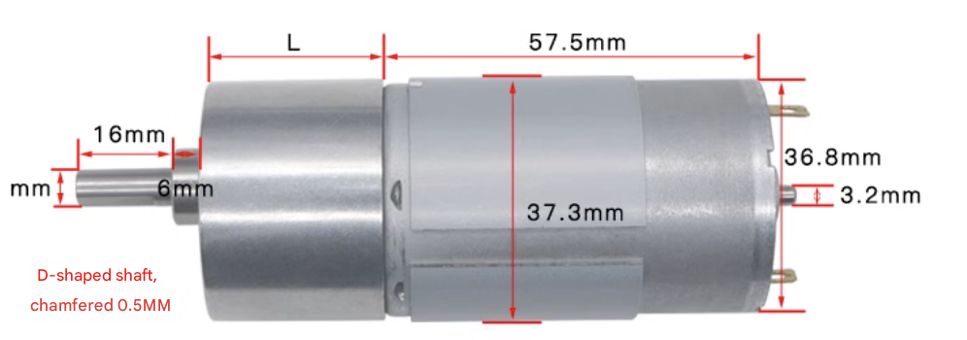

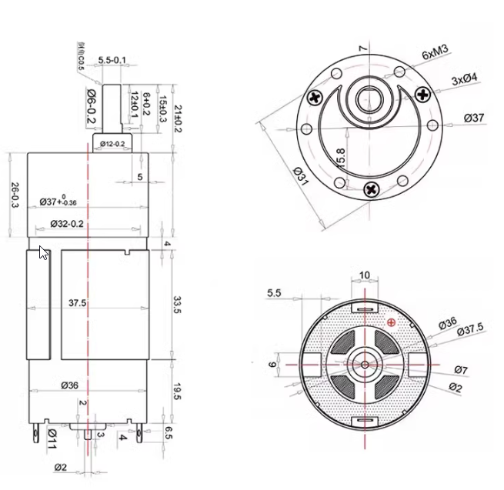

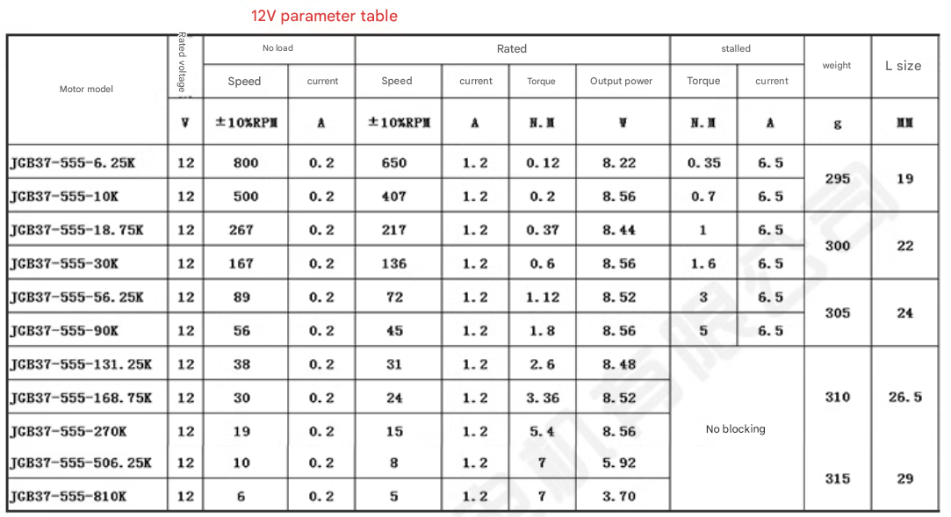

Precautions for using the motor:

1. Before use, make sure the motor voltage is correct. If it is a DC motor, make sure the power supply current is sufficient.

2. Do not overload. The reasons for overload are mainly divided into two parts: torque and shaft force. The load torque cannot exceed the rated torque of the motor, and the shaft force cannot exceed the axial and radial allowable forces of the shaft. After adding load, the actual measured current of the motor cannot exceed the rated current. Generally, the motor must be equipped with a fuse to avoid overload and burning the motor.

3. Do not store or operate in a high temperature or humid environment, and do not place it in corrosive gas, which will reduce the motor effect.

4. When assembling transmission parts such as gears and pulleys on the motor shaft, do not knock them abnormally when pressing them in.

5. When soldering the positive and negative motor terminals of the power supply, the soldering iron temperature should be 340℃±40℃ and the heating time should be within 3 seconds. Do not deform the plastic. During work, do not allow the solder to flow into the motor or break the end of the wire, which will cause the motor function to decline.

6. When installing the motor, pay attention to whether the screws are too long to prevent the long screws from pressing the parts inside the motor.