Colorful Christmas tree LED flow light kit
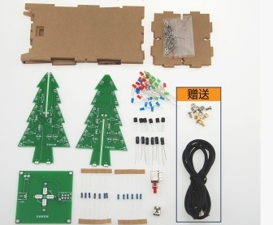
Product Description
The Christmas Tree Kit consists of a combination of three circuit boards that the user assembles by soldering and assembling themselves, allowing the 36 LEDs to flash alternately, presenting a three-dimensional silhouette of a Christmas tree in space (better when viewed in nighttime environments).

Specification parameters
Working voltage: DC4.5-5V
Power supply: 3 x 5 batteries, cell phone charger, computer, rechargeable treasure
Overall dimensions (including shell): L72mm × W72mm × H140mm
Circuit board material: double-sided 1.6mm RF-4 board.

Small Christmas tree lights welding points of attention
Colorful lights version: by 32 of the same white hair transparent LED lights welded composition, in the light will be regular color changes, individual customers test just light up to see is red will be misunderstood, test to light up more seconds to see the colorful lights of the change Oh, welding position does not distinguish between the arbitrary position welding, long foot for positive.
Three-color light version: consists of three different colors of monochrome lights, welding position to distinguish, please download the list below and watch the video welding.

Working Principle
The circuit principle is as follows:
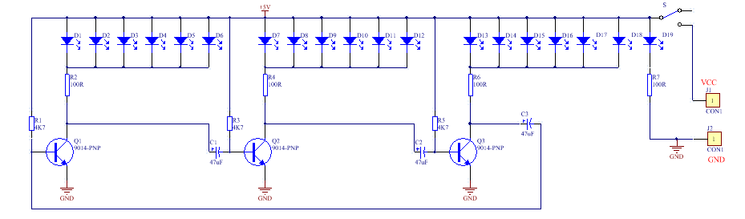
As can be seen from the schematic diagram, when connected to the 3-5V power supply, 18 LEDs are divided into three groups, whenever the power supply is turned on, three transistors will compete for the first conduction, but due to the differences in components, only one transistor first conduction, here assuming that the Q1 first conduction, the LED1 this group of light, due to the Q1 conduction, the voltage drop in its collector so that the capacitance of the C2 left end of the drop, close to 0V, due to Capacitor voltage can not be changed abruptly, so the base of Q2 is also received to approximate 0V, Q2 cutoff, so connected to its collector LED2 this group off; at this time, the high voltage of Q2 through the capacitor C3 so that the collector voltage of Q3 rises, Q3 will also be rapidly conductive, the LED3 this group of light, so in the period of time, Q1, Q3's collector is a low level, the LED1 and LED3 this group of two LED2 this group is off, but with the power supply through the resistor R2 charging C2, Q2 base voltage gradually rises, when more than 0.7V, Q2 from the cutoff state into a conduction state, the collector voltage drops, LED2 this group of light, and at the same time, Q2's collector voltage drops through the C3 matter Q3's base voltage is also lowered, Q3 from the conductive into the cutoff, the collector voltage rises, LED3 this group of light. Voltage rise, LED3 this group off, next, the circuit in accordance with the above description of the process cycle, three groups of 18 LEDs will take turns to light, the same time there are two groups are lit, these LEDs are cross-arrayed into a heart-shaped pattern, the continuous cycle of flashing light, to achieve the effect of the flow of the display.

Component List
Christmas tree A-board
Name | Model | No. | Qty | Name | Model | No. | Qty
Resistor | 100R | R2/R4/R6/R7 | 4 | LED | Red | D1-D6 | 7
Resistor | 4.7K | R1/R3/R5 | 3 | LED | Green | D7-D12 | 6
Capacito | 47uf | C1/C2/C3 | 3 | LED | Blue | D12-D18 | 6

Christmas Tree B Board
Name | Model | No. | Qty | Name | Model | No. | Qty
Resistor | 100R | R2/R4/R6 | 3 | LED | Red | D1-D6 | 6
 | 4.7K | R1/R3/R5 | 3 | LED | Green | D7-D12 | 6
Capacito | 47uf | C1/C2/C3 | 3 | LED | Blue | D12-D18 | 6
Triode | 9014 | Q1/Q2/Q3 | 3 | PCB Board | 1 | Christmas Tree B Board | 1

Name | Model | No. | Qty | Name | Model | No. | Qty
Switch | Self-locking | S | 1 | Nut | 3mm | 4 | 4
Power supply holder | USB holder | P1 | 1 | Power cable | USB to DC | 1 | 1
Copper post | 1 | 4 | 4
Christmas Tree Base Board

Welding Procedure
Ⅰ. Christmas tree A, B board welding (two boards welding method is the same, two boards compared to the B board less R7)
1, Welding 100R resistor (no direction, the shipment of the resistor is marked, do not weld the wrong oh)
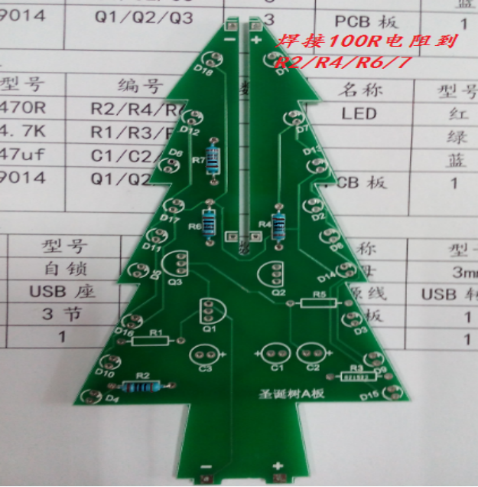
2, Welding 4.7K resistor (no direction, the shipment of resistors on the marked, do not weld the wrong oh)
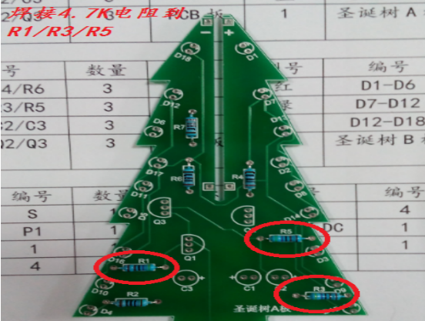
3, Welding 9014 (with direction, against the circuit board silkscreen direction welding)
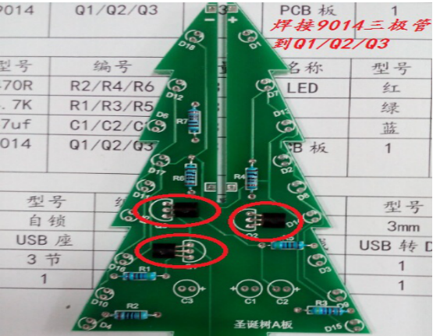
4, Welding 47uf electrolytic capacitor (with direction, long leg is positive)
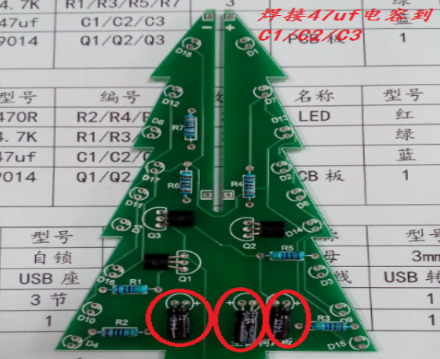

5, Welding LED, three-color light version to the list of lights position into the welding, seven-color lights are the same welding where you can (with the direction of the long foot is positive, welding iron can not be welded at the same time the LED two pins)
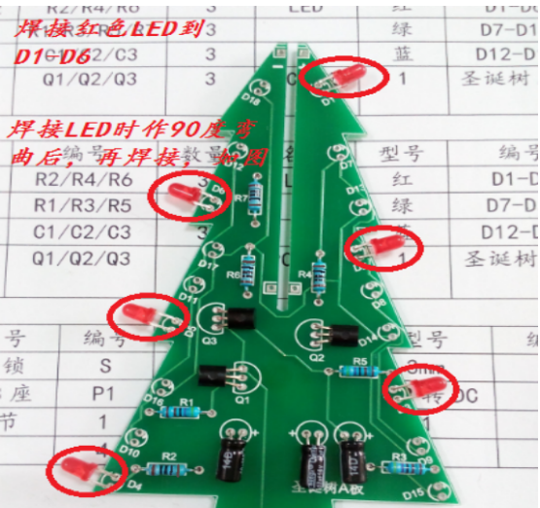
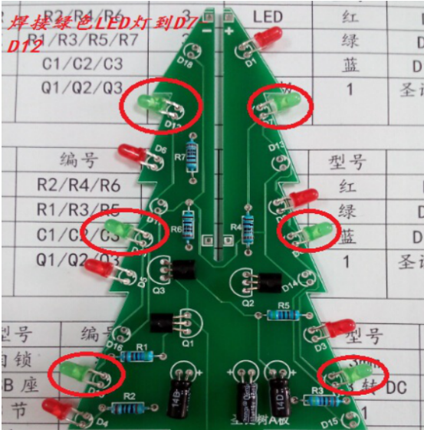
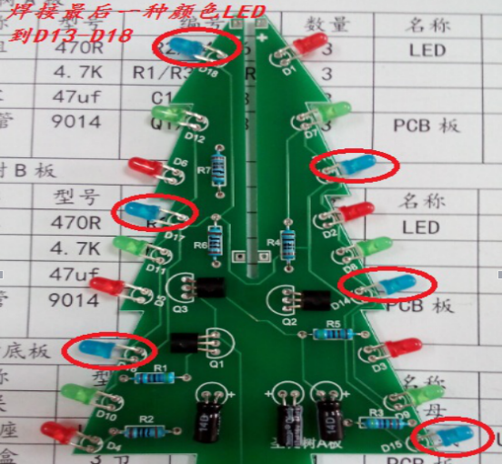
6, Welding the top led, three-color light version of the red to be used (Note: need to merge the A, B board and then welded)
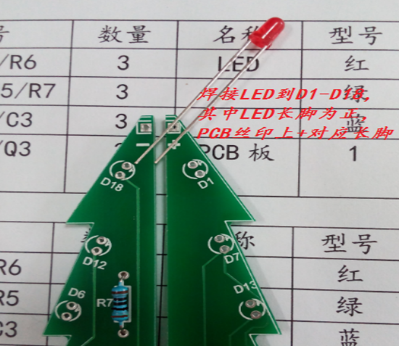
Ⅱ. Welding Christmas tree base plate
Solder the bottom plate silkscreen P1 to the power plug and S to the self-locking switch.
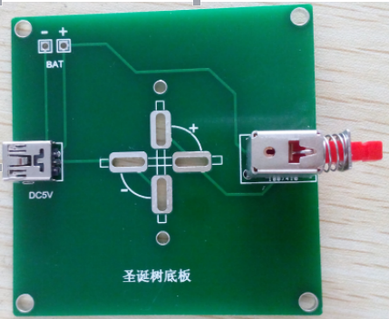

Ⅲ. Schematic diagram of connection of A and B plates and base plate
The "+" sign corresponds to the "+" sign when plates A and B are clamped (as seen from the self-locking switch side).
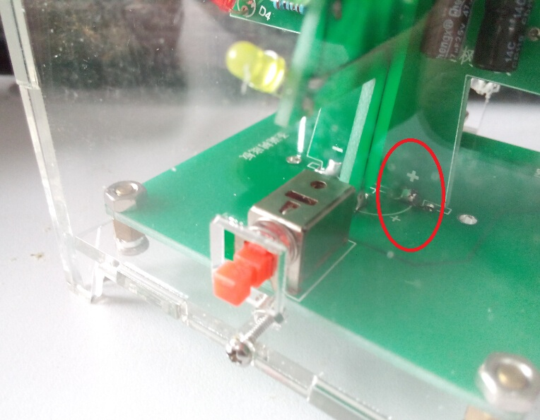

The "-" sign corresponds to the "-" sign (as seen from the power connector side)
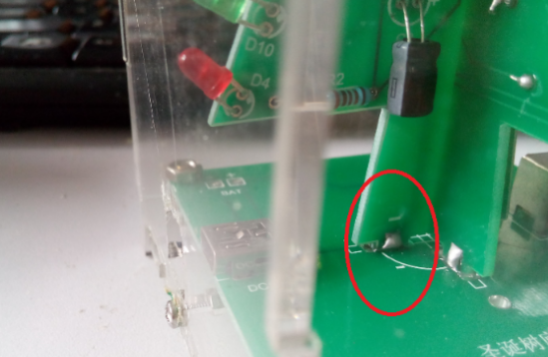

Ⅳ. Assembling the shell
The method of fixing the housing is to put the screws in place first and then screw them in.
