5V/7-28V ESP8266 WIFI 8 Channel Relay Module ESP-12F Development Board Power Supply Wireless WIFI Module
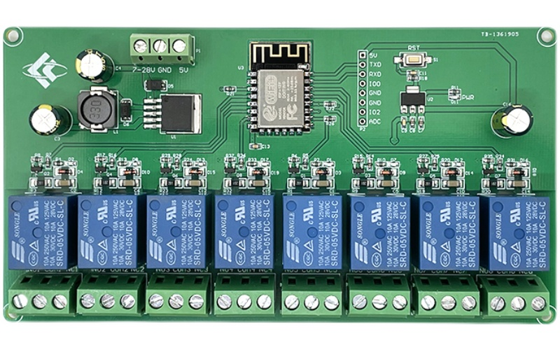
Overview
ESP8266 eight-way relay development board equipped with ESP-12F WiFi module, support DC7-28V/5V power supply mode. Provide Arduino development environment reference code, suitable for ESP8266 secondary development learning, smart home wireless control and other occasions.
Functional features
1, on-board mature and stable ESP-12F WiFi module, high-capacity 4M Byte Flash;
2, the power supply mode supports DC7-28V/5V;
3, on-board WiFi module RST reset button;
4, ESP-12F support the use of Eclipse/Arduino IDE and other development tools, to provide reference programs under the Arduino development environment;
5, on-board 8-way 5V relay, output switching signals, suitable for controlling the control of loads operating voltage of AC 250V/DC30V or less;
6, on-board power indicator and relay indicator.

Hardware introduction and description
1, board size: 148 * 79.8mm
Weight: 140g
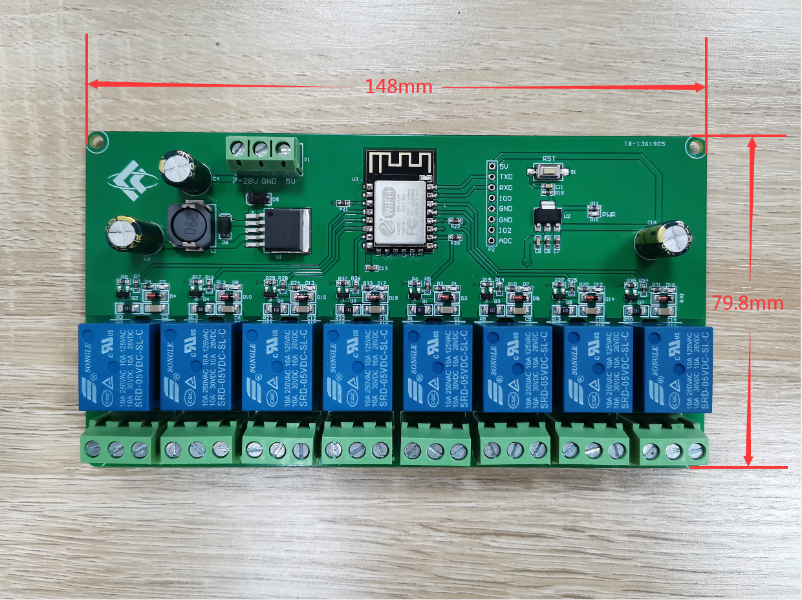
2, Interface Introduction
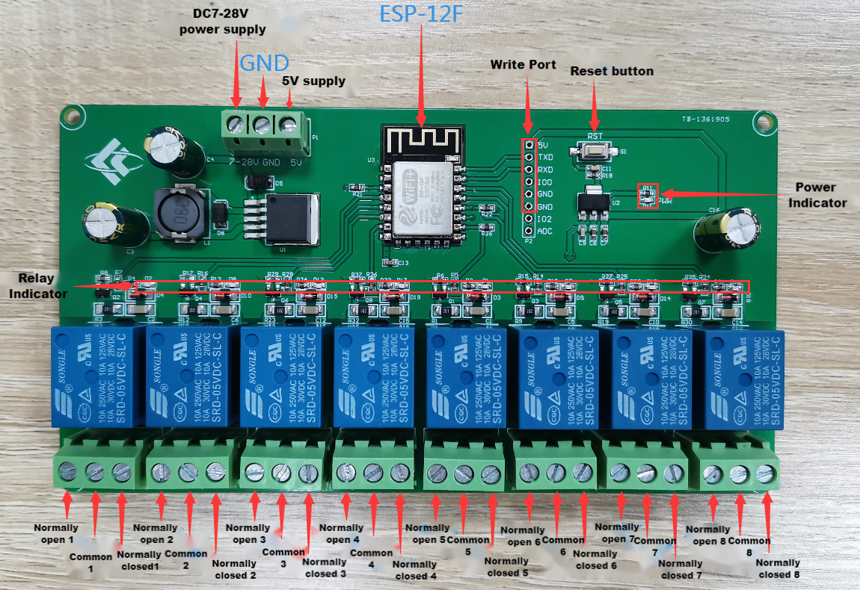
Burning port: GND, RX, TX, 5V of ESP8266 are connected to GND, TX, RX, 5V of the external TTL serial module respectively, IO0 needs to be connected to GND when downloading, and then disconnect the connection between IO0 and GND after downloading is completed;
Relay output:
NC: normally closed terminal, shorted to COM before the relay is absorbed, suspended after absorption;
COM: common terminal;
NO: Normally open terminal, the relay is suspended before it is absorbed, and is shorted to COM after it is absorbed.
3, Introduction of GPIO pinout ports
serial number | name | Functional Description
1 | ADC | A/D conversion result. Input voltage range 0 to 1V, value range: 0 to 1024
2 | IO2 | GPIO2; UART1_TXD
3 | TXD | UART0_TXD; GPIO1
4 | RXD | UART0_RXD; GPIO3
5 | GND | POWER GROUND
6 | 5V | 5V Power Supply

4, Arduino development environment construction
ESP8266 supports Eclipse/Arduino IDE and other development tools, the use of Arduino to be relatively simple, the following is the Arduino development environment to build methods:
1, install Arduino IDE 1.8.9 or the latest version;
2, open the Arduino IDE, click the menu bar File - Preferences, enter the Preferences in the "additional development board manager URL" in the click to add the URL:
http://arduino.esp8266.com/stable/package_esp8266com_index.json,
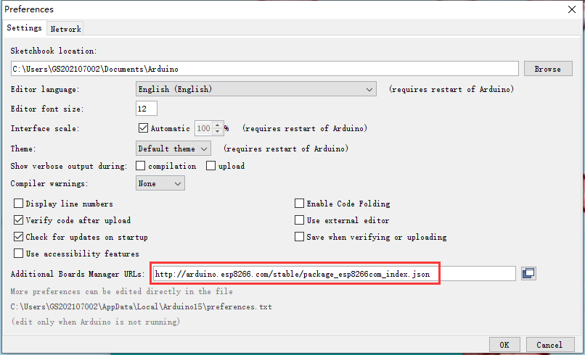
3, click the menu bar of the Tools - Development Board - Development Board Manager, and then search for "ESP8266" to install the Arduino ESP8266 support package 3.1.2 or the latest version!
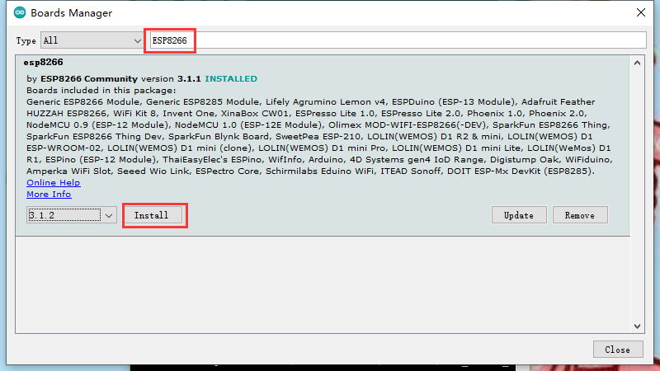

5, program download
1, use the jumper cap to connect IO0 and GND pins, prepare a TTL serial module (eg: FT232) plugged into the computer USB, serial module and the development board connection method is as follows:
TTL Serial Module | ESP8266 Development Board
GND | GND
TX | RX
RX | TX
5V | 5V
2, click the menu bar Tools - Development Board, select the development board for ESPino (ESP-12 module)
3, open the program you want to download, click Tools - Port in the menu bar, select the correct port number.
4, click "Upload" and the program will be automatically compiled and downloaded to the development board, as follows:
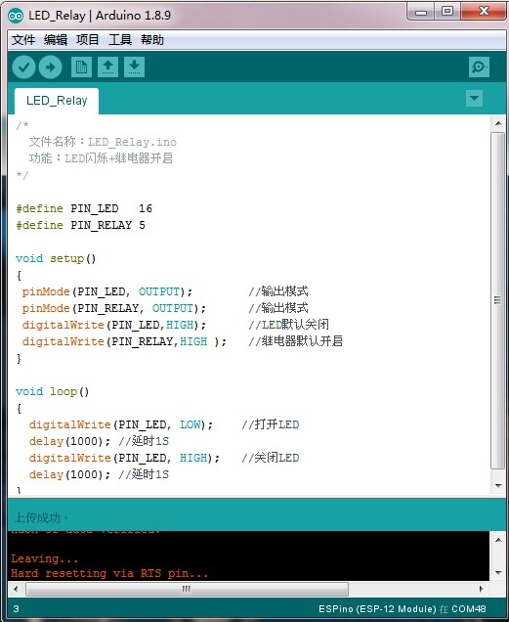
5, and finally disconnect IO0 and GND, the development board re-power or press the reset button program can run.

