1 Application
This single phase electronic DIN rail active energy meter is a kind of new style single phase two wire active energy meter, it adopt micro-electronics technique, and imported large scale integrate circuit, use advanced technique of digital and SMT techniques, etc. It has its completely independent intellectual property rights and minimum size. The meter completely accord with relevant technical requirements of class 1 single phase active energy meter stipulated in international standard IEC 62053-21. It can accurate and directly measure 50Hz or 60Hz active energy consumption from single phase AC electricity net. This meter has white backlight source eight digits LCD displays shows the active energy consumption. It has following features: good reliability, small volume, light weight, specious nice appearance, convenient installation, etc. This meter has already got the patent certificate from China State Intellectual Property Office at present. Patent certificate NO. ZL 2012 3 0473501.3, any other country patent certificate are in assessing.
2 Function and specification
√ 35mm standard DIN- rail installation , complying with standard DIN EN50022。
√ Bipolar width (Modulus 17.5mm), complying with standard DIN43880。
√ Standard configuration 6+1 digits display (999999.1kWh)LCD。
√ May select function(display voltage、current、power、frequency、power factor)。
√ Two LED instructions power supply state (green) and signal of energy impulse (red)。
√ Single direction measurement single phase two wire active energy consumption. It is nothing with direction of the flow of load current. Complying with standard GB/T17245.321-2008。
√ Directly connect operation, there are two types wiring you may select. Standard configuration type S wiring, may select type U wiring .
√ DDS528LSeries :Direct connection, up-entering and down-out, up-out and down-in, you can install, the standard configuration S-type wiring。
√ DDS528LSeries:Embedded terminal cover, nice, safe to protect electricity。

3 Main technical parameters
Type | Accuracy | Rated voltage | Rated current | Starting Current | Insulating performance
DDS6619  DDS528L | Class 1.0 | 220V | 5(32) A | 0.04% | Frequency AC voltage 2kv lasted 1 minute, the impact voltage 6kv

4 Basic error:
Phase balance load
0.05Ib Cosφ = 1 ±1.5%
0.1Ib Cosφ = 0.5L ±1.5%
Cosφ = 0.8C ±1.5%
0.1Ib - Imax Cosφ = 1 ±1.0%
0.2Ib - Imax Cosφ = 0.5L ±1.0%
Cosφ = 0.8C ±1.0%

5 Outline and wiring diagram

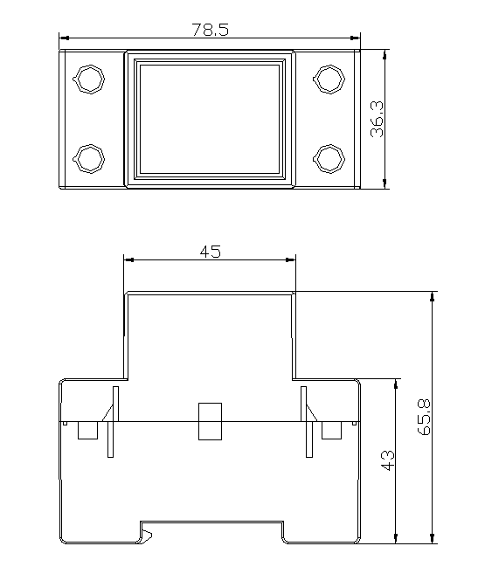

Wiring diagram (Type S)
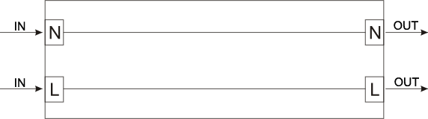
6 Troubleshooting
Fault condition check solution
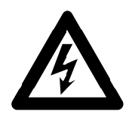
WARN
♦ In the repair or maintenance process, do not use hand, metal, bare wire contact meter wiring, to prevent the shock.
♦ Be sure to disconnect the power supply to the meter and disconnect the power supply from the meter installation before servicing.


Danger
♦ Only qualified personnel who are familiar with the relevant operation and procedures can carry out maintenance of this meter.
♦ Maintenance with insulating tools
♦ Ensure that the protective cover is restored after repair.
♦ Do not damage the seal of the meter

Fault conditions | Check | resolve
LCD Do not take the word | Whether the meter is connected to the power supply is too low power consumption  There may be a problem with the internal circuit | Check that the pulse signal is not flashing  When the power is too low, LCD screen to be separated for a long time to appear digital changes  Please contact your technical support staff to change a meter
No pulse output | Whether connected to the DC power supply  There may be a problem with the internal circuit | Check if the external voltage is 5-27V DC  Please contact your technical support staff to change a meter
Pulse output error | There may be a problem with the internal circuit | Please contact your technical support staff to change a meter
7 . Transport and storage

In the transport and unpacking products should not be a severe impact, and in accordance with GB / T15464-1995 "instrumentation packaging general technical conditions" and JB / T 9329-1999 "instrumentation transport, transport and storage of basic environmental conditions and test methods" Transport and storage. Inventory and storage should be stored in the original packaging conditions on the bracket, stack height should not exceed 5 layers. Preservation should be clean, the ambient temperature should be (0 ~ 40) ℃, relative humidity of not more than 85%, and in the air does not contain enough to cause corrosion of harmful substances.

8 After-sales service
Within 12 months from the date of manufacture the user complies with all of above rules. If the meter still being sealed does not conform to any technical requirements of IEC 61036, or of any certification of Power Department or Measuring Department, the manufacture guarantees to repair freely or to change.

