12V dual bluetooth relay module

LC-WM-Relay -12V-2

12V dual Bluetooth relay iot smart home phone APP remote control switch

**An overview,**

**Elsay 12V dual Bluetooth relay module includes two 12V/10A relay module and SPP-C Bluetooth serial port slave module. The switch of the relay can be controlled by sending instructions through the APP of the mobile phone.**

**Two, functional characteristics**

**1. Onboard 8-bit high performance microcontroller chip and SPP-C Bluetooth 2.1 slave module;**

**2. Provide Bluetooth relay control APP;**

**3, control distance: 10M (open environment);**

**4, working voltage: DC12V;**

**5, onboard 2 channels 12V,10A/250V AC 10A/30V DC relay, can be continuously suction 100000 times, with diode shedding protection, short response time;**

**6. Onboard Bluetooth status indicator and relay indicator;**

**7. Reserve UART debugging interface and MCU program download interface.**

**3. Hardware introduction and description**

**Board size: 40*64.5mm**

**Board function description:**

**1. Introduction to onboard resources:**

**IN+, IN- : 12V power input;**

**TX, RX: UART serial port pin;**

**5V, GND, SWIM, NRST: microcontroller program download port.**

**LED D2/D4 (red light) : relay working indicator light, lit when open**

**LED D1 (blue light) : Bluetooth status indicator, described as follows:**

**(1) Slow blinking indicates waiting for the connection to be established with the mobile phone;**

**(2) When it is steady on, it indicates successful connection with the mobile phone.**

**The reserved two jumper caps: Connect them to the right end (RX to RX1, TX to TX1) in normal use. If you want to use the USB-to-TTL serial port module to debug the SPP-C module alone, connect them to the left end (otherwise, interference may occur).**

**COM1: common end;**

**NC1: normally closed end, the relay is short connected with COM1 before pulling, and suspended after pulling;**

**NO1: normal beginning, the relay is suspended before pulling, and short connected with COM1 after pulling.**

**COM2: common end;**

**NC2: normally closed end, the relay is short connected with COM2 before pulling, and suspended after pulling;**

**NO2: normal beginning, the relay is suspended before pulling, and short connected with COM2 after pulling.**

**Relay control instructions (in HEX form) :**

**Open the first relay: A0 01 01 A2**

**Close the first relay: A0 01 00 A1**

**Switch on the first relay: A0 02 01 A3**

**Close the first relay: A0 02 00 A2**

**1. Connect the power supply: IN+ and IN- of the module are respectively connected to the positive and negative poles of the 12V power supply**

**2. Use APP to control the 2-way relay**

**There are two apps available: one is a Bluetooth relay special APP developed by Elsay Electronics, and the other is a universal APP downloaded from Android APP Store.**

**2.1 Instructions for using Bluetooth relay special APP:**

**2.1.1 Install "LCBS Test Program" APP and Bluetooth serial port transmission tool on Android mobile phone, open the APP, click "Search Bluetooth", connect the mobile phone to the Bluetooth module, enter the password and click confirm. After successful connection, the blue light will change from slow flashing to steady on, and then click the box to control the relay switch.**

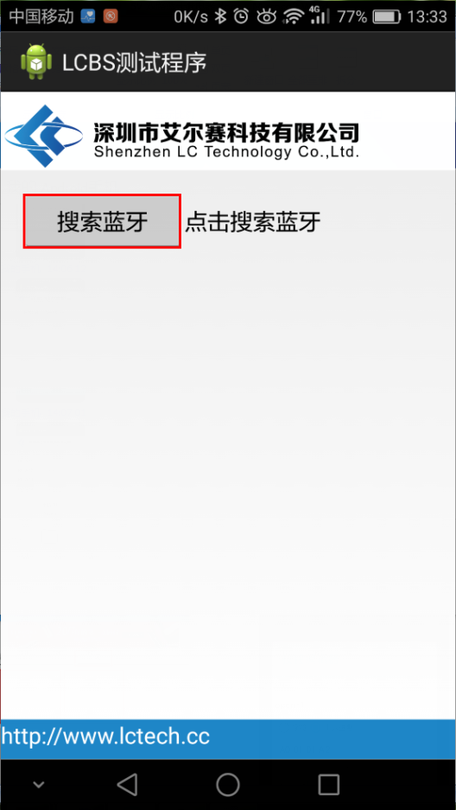 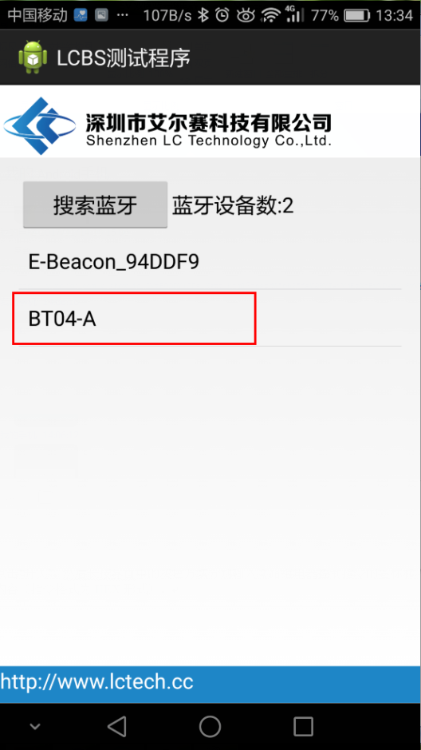

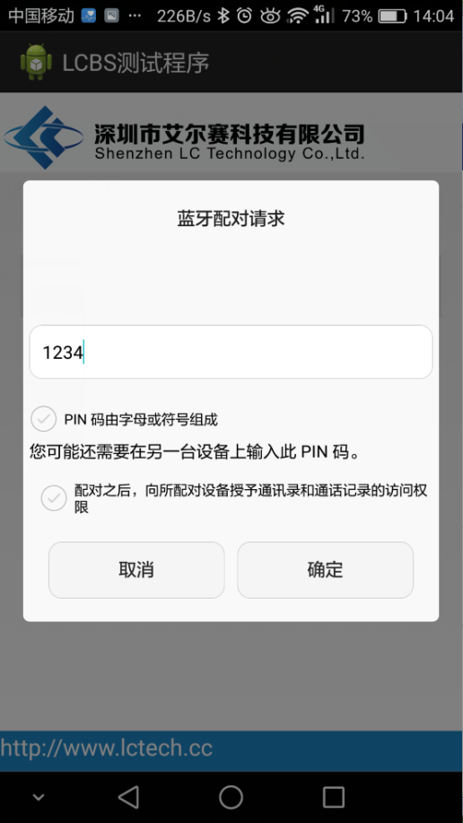 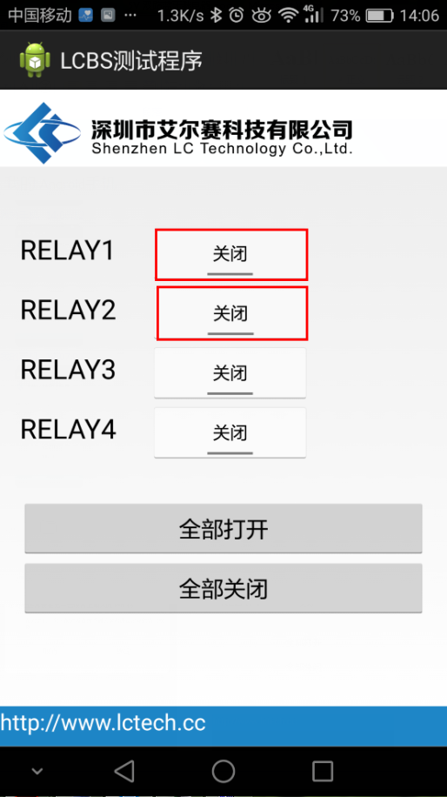

2.2. Instructions for Bluetooth relay Universal APP:

2.2.1 Install APP "BlueSPP_37" on Android phone, Bluetooth serial port transmission tool, which is used to send relay control commands. Click "Switch", and then long press the gray square on the interface to input the name and content of the two relay control commands respectively (instruction format is HEX).

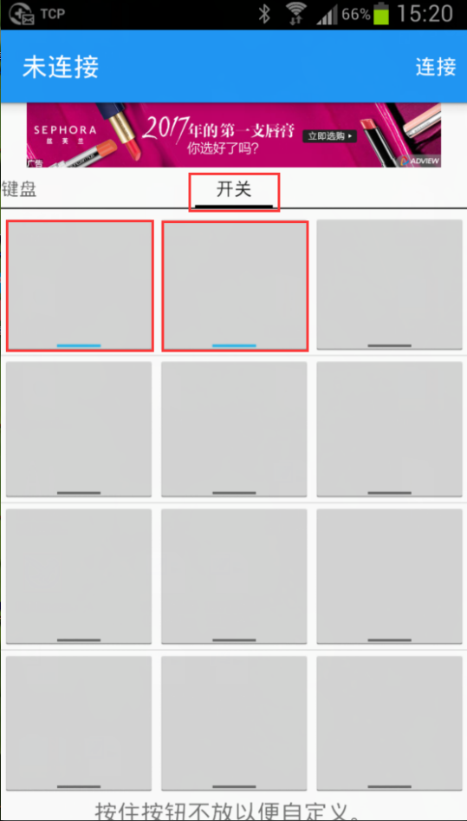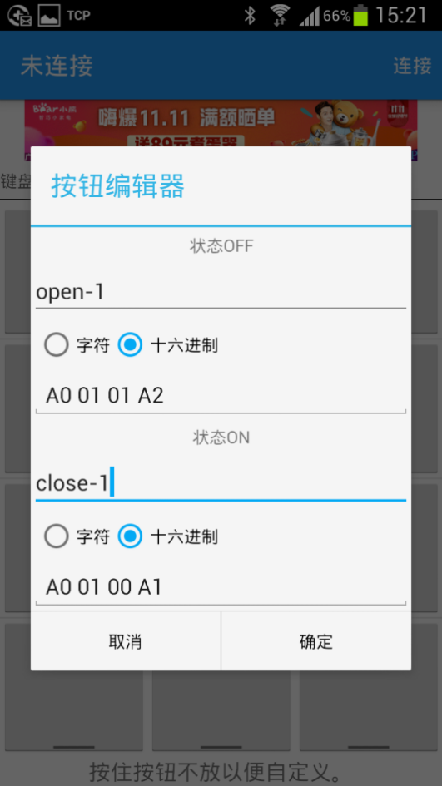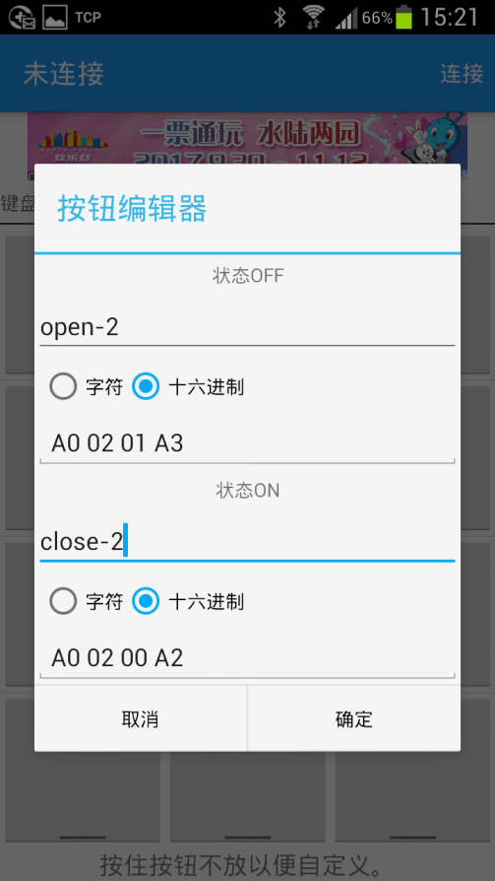 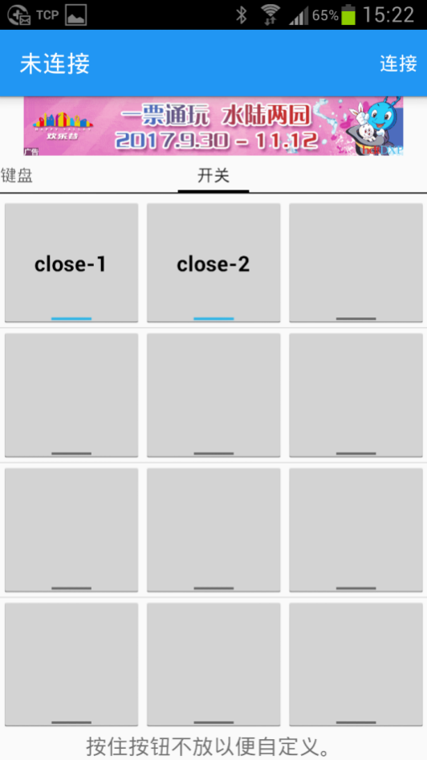

2.2.2 Open the "BlueSPP_37" APP and click "Connect" to connect the mobile phone to the Bluetooth module (initial password is 1234). After successful connection, the blue light will change from flashing to steady on. Click the gray square to send instructions to control relay switch.

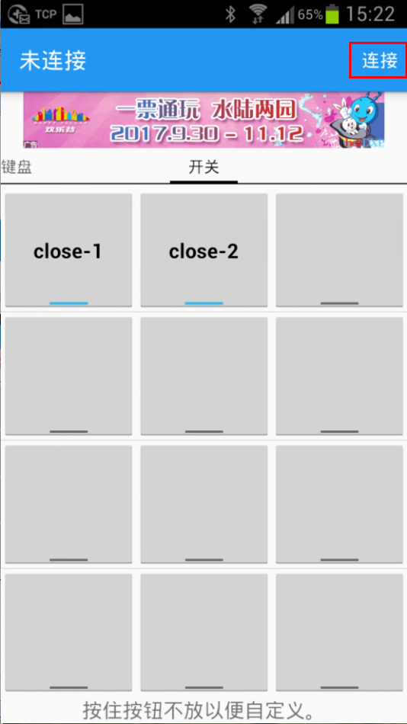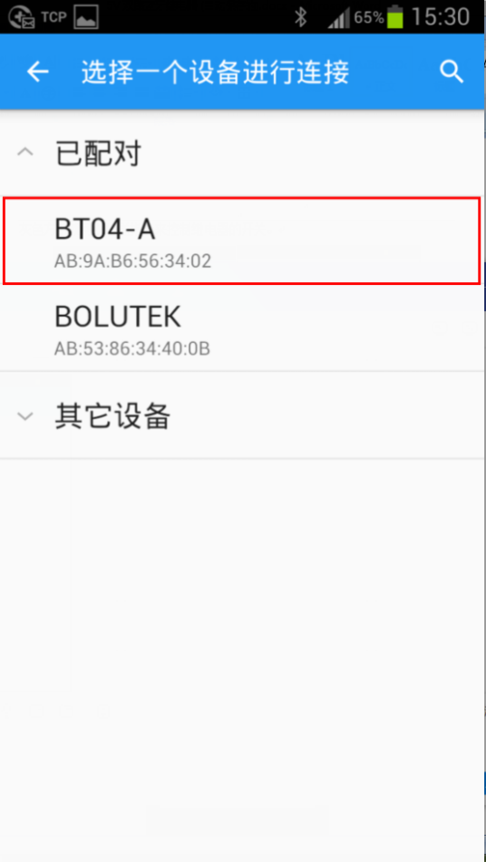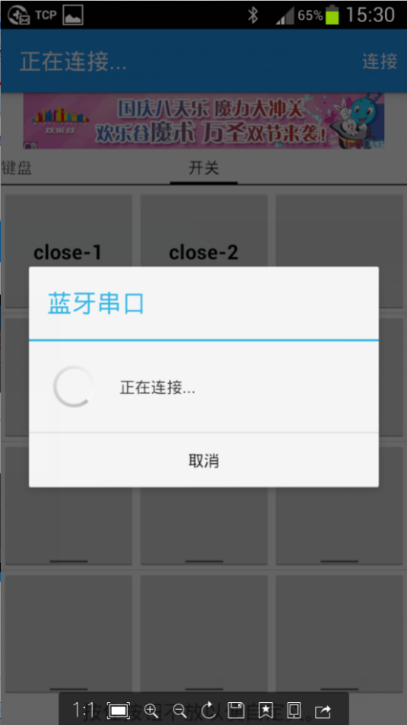 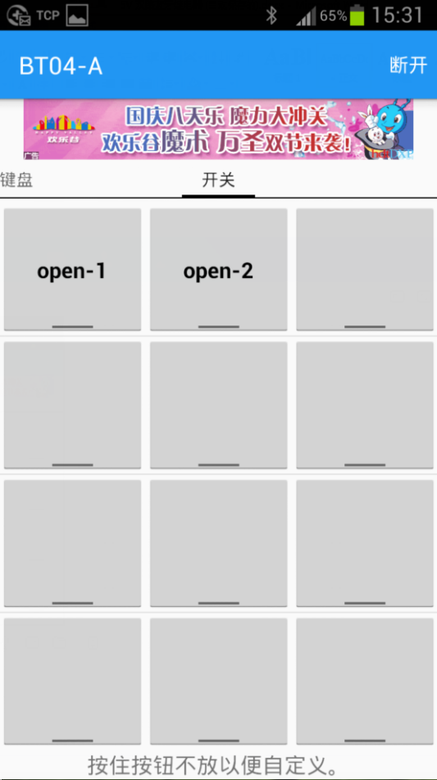

3. Instructions for additional functions (as USB relay) :

Prepare a USB-to-TTL serial port module. Connect the GND, TX, and RX of the TTL module to the GND, TX, and RX of the relay module respectively (if there is no response, try to switch TX and RX). Open the serial debugging software (such as SSCOM32) on the computer and set the baud rate to 9600. When A0 01 01 A2 and A0 02 01 A3 are sent in hex mode, the first and second relays can be opened respectively. Sending A0 01 00 A1 and A0 02 00 A2 in hex mode can close the first and second relays, respectively. Take opening the relay as an example: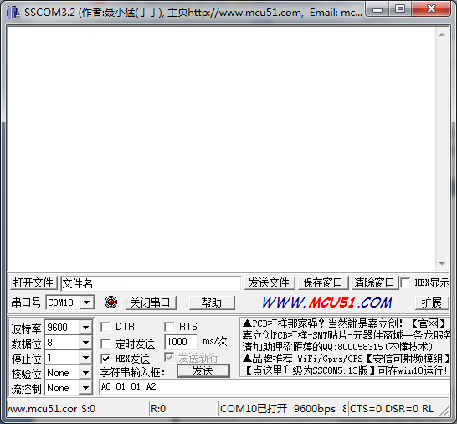

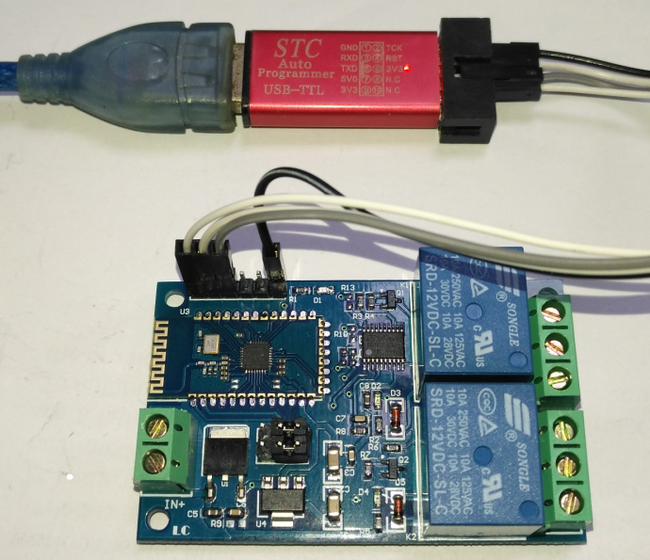

4. How to change the Bluetooth name and password (5V for example) :

Wiring method: 5V,RX,TX, and GND on the Bluetooth relay module are connected to the USB-to-TTL serial port module 5V,TX,RX, and GND respectively (if there is no response when sending serial port instructions, you can try to exchange TX and RX), and modify Bluetooth related parameters by sending AT instructions.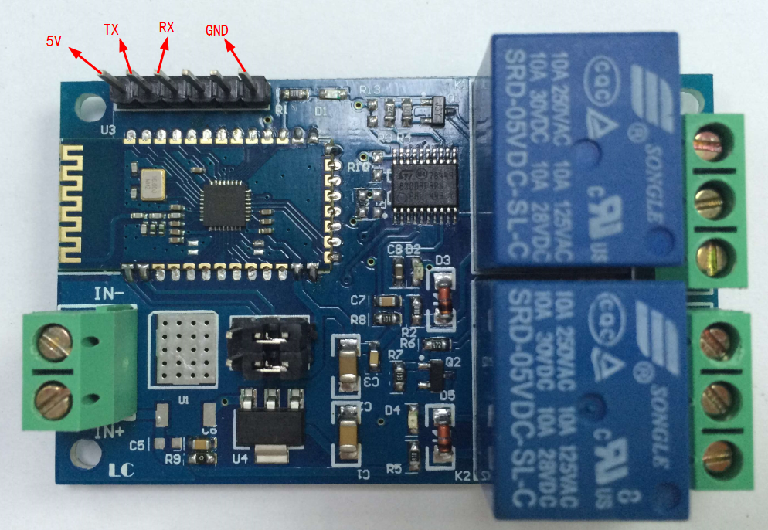

(1) Change the password: If you want to change the password to 8888, open the serial debugging assistant software on the computer (for example, SSCOM32, select the baud rate 9600, tick "Send new line"), type AT+PIN8888, and click Send.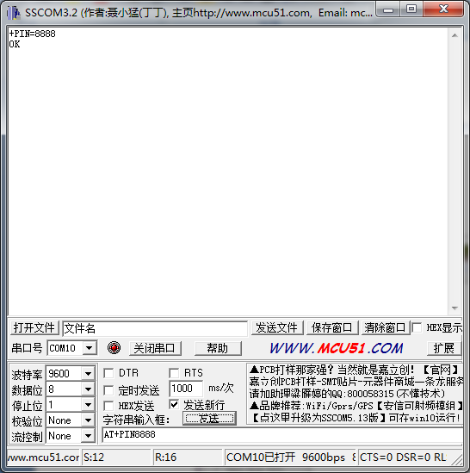

(2) Modify the Bluetooth name: If you send AT+NAMEBOLUTEK, you can change the name to BOLUTEK, and then send AT+RESET to make the new name take effect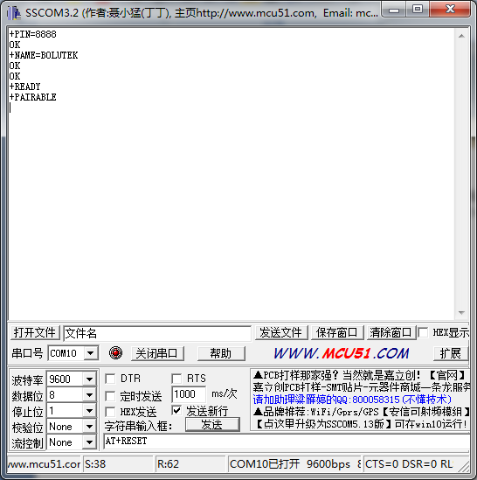

For more AT instructions, see the SPP-C data book in the Resources section