**2 x 18650 Lithium Battery Shield V8 Mobile Power Expansion Board Module 5V/3A 3V/1A Micro USB for Arduino ESP32 ESP8266**

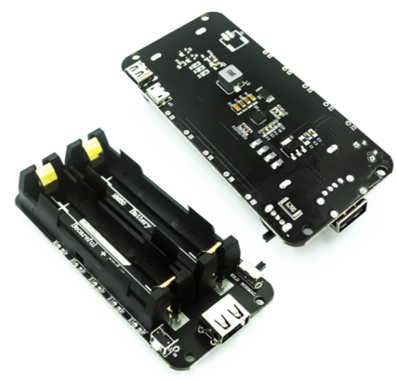

**Product Description**

The module is a portable mobile power supply that supports two voltage outputs, 3V/1A and 5V/2.2A.

Micro USB port input

Type A USB output

0.5A current charging

1 switch to control USB output 5 ~ 8v input voltage

LED Indication (Green color indicates, Red color indicates charging)

3v output port X3

5V Output Port X3 Be careful with the "+" and "-", you should follow the direction "+" and "-" on the PCB.

**Description of interfaces and components**

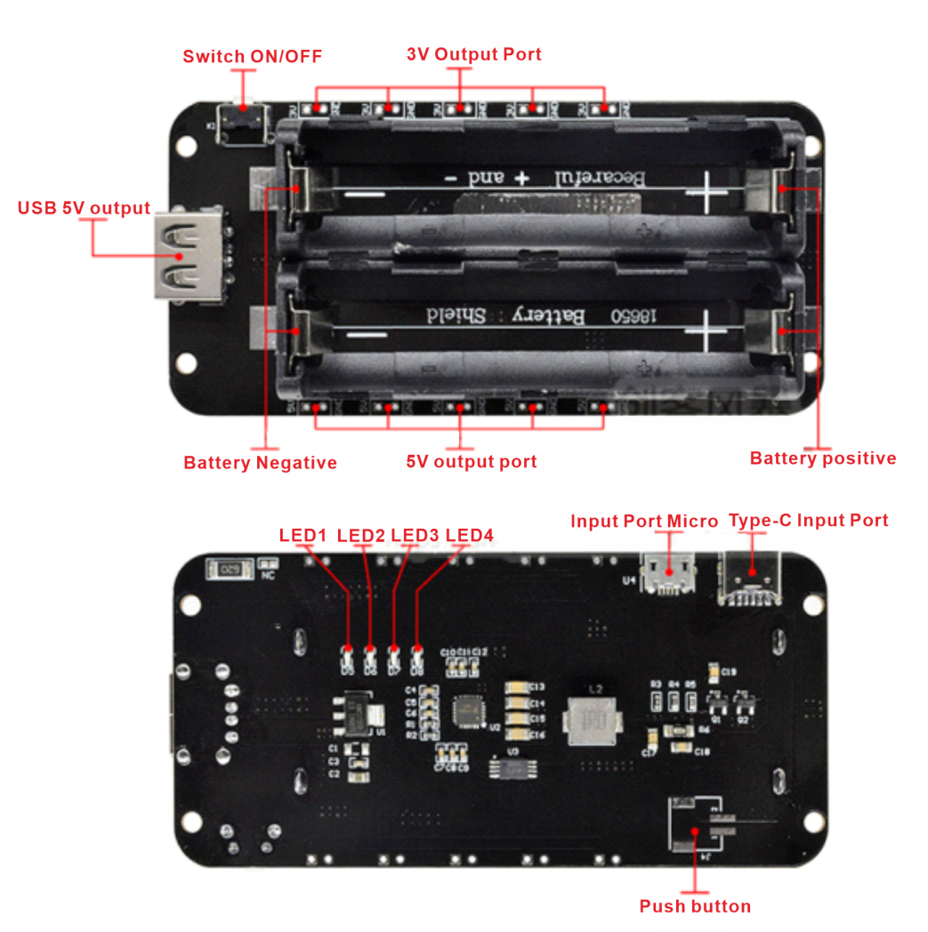

**Instructions for use**

Rated current for 5V voltage output is 2.2A

Maximum support 3A current (not recommended for over

load, easy to damage the module and speed up the service life)

The current output depends on the quality of the 18650 battery!

MICRO USB charging current 600mA-800mA, support up to two 18650 batteries.

It is recommended to use two 18650 batteries, which can be longer!

When the switch is toggled to NOMAL, the current output is lower than 30ma, it will automatically stop and turn to standby mode in about 10 seconds. When the switch is flipped to HOLD, it will stay on no matter what the situation is, until the battery is dead (the 2512 resistor on the back will get hot).

Special Note: Battery installation must determine the positive and negative poles, the board has clearly marked positive and negative poles! Incorrect installation will burn the module!

**Dimensional drawings**

