How to install Optical fiber on the convert board ?

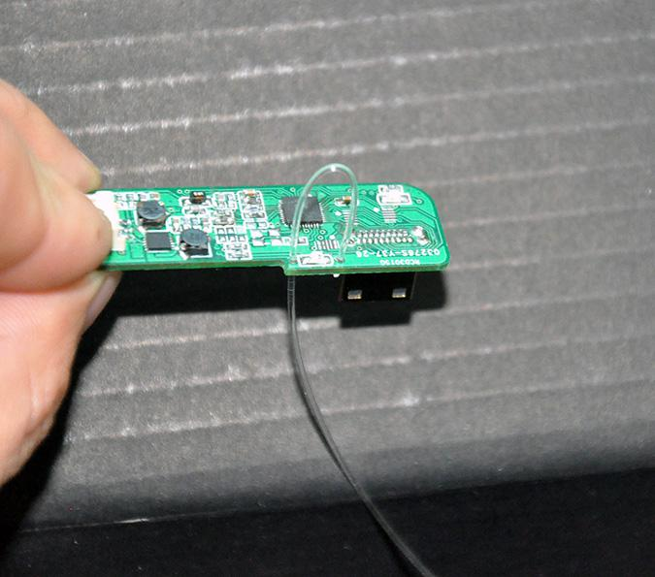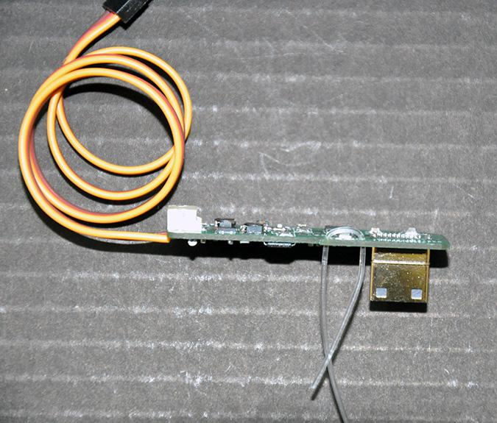

1. Insert the optical fiber to two holes beside the infrared LED.

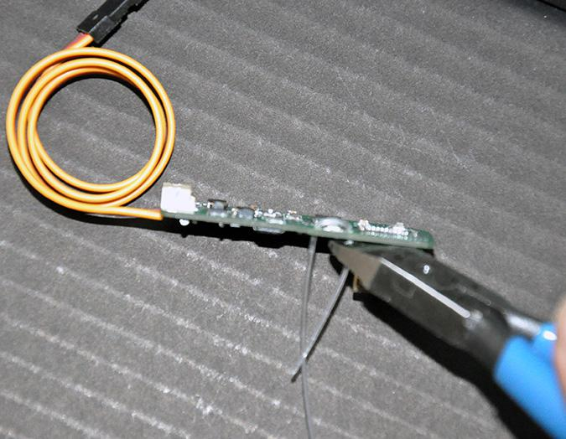

2.Taut fiber, let optical fiber close  to infrared LED.

3. Cut unwanted parts of optical fiber, the rest please keep good, for next time use.

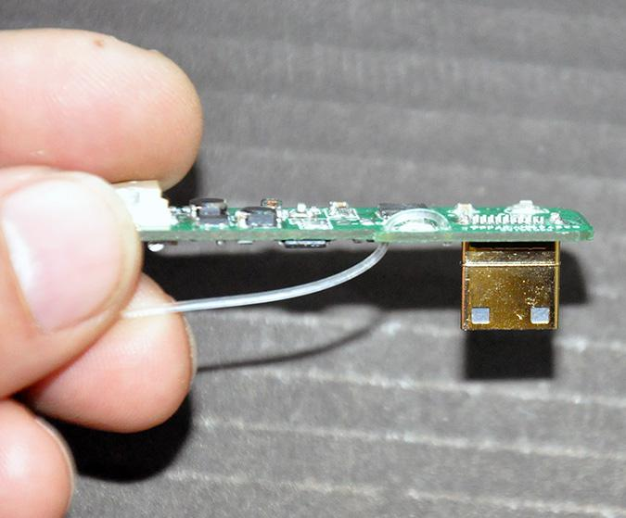

**Note that optical fiber can't walk hard right-angle bend, otherwise easy to broken.**

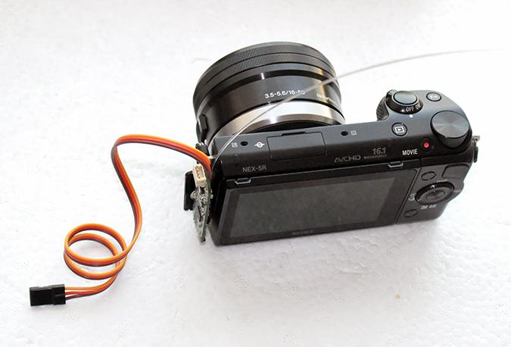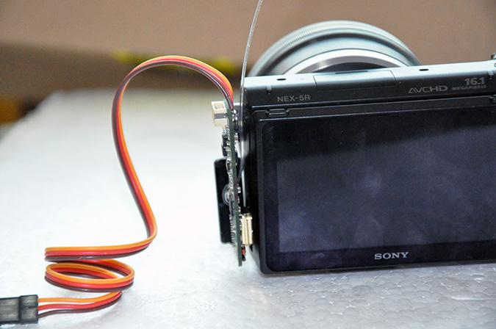

4、Mount the RCD3015G to camera.

5. According to the length of the need, and then cut fiber to the appropriate length.

6. Use adhesive tape to mount optical fiber to infrared window of the camera.

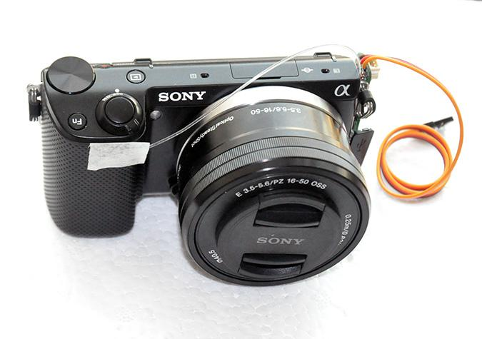

7. The next step is to set the camera into the infrared remote control mode.

