4 Channel Relay Module 30A with Optocoupler Isolation 12V Supports High and Low Triger

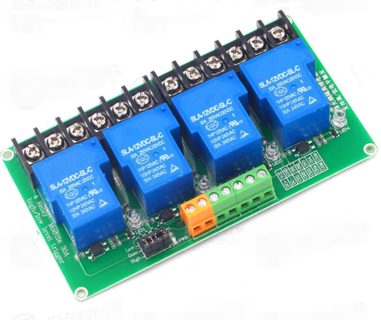
Interface Description
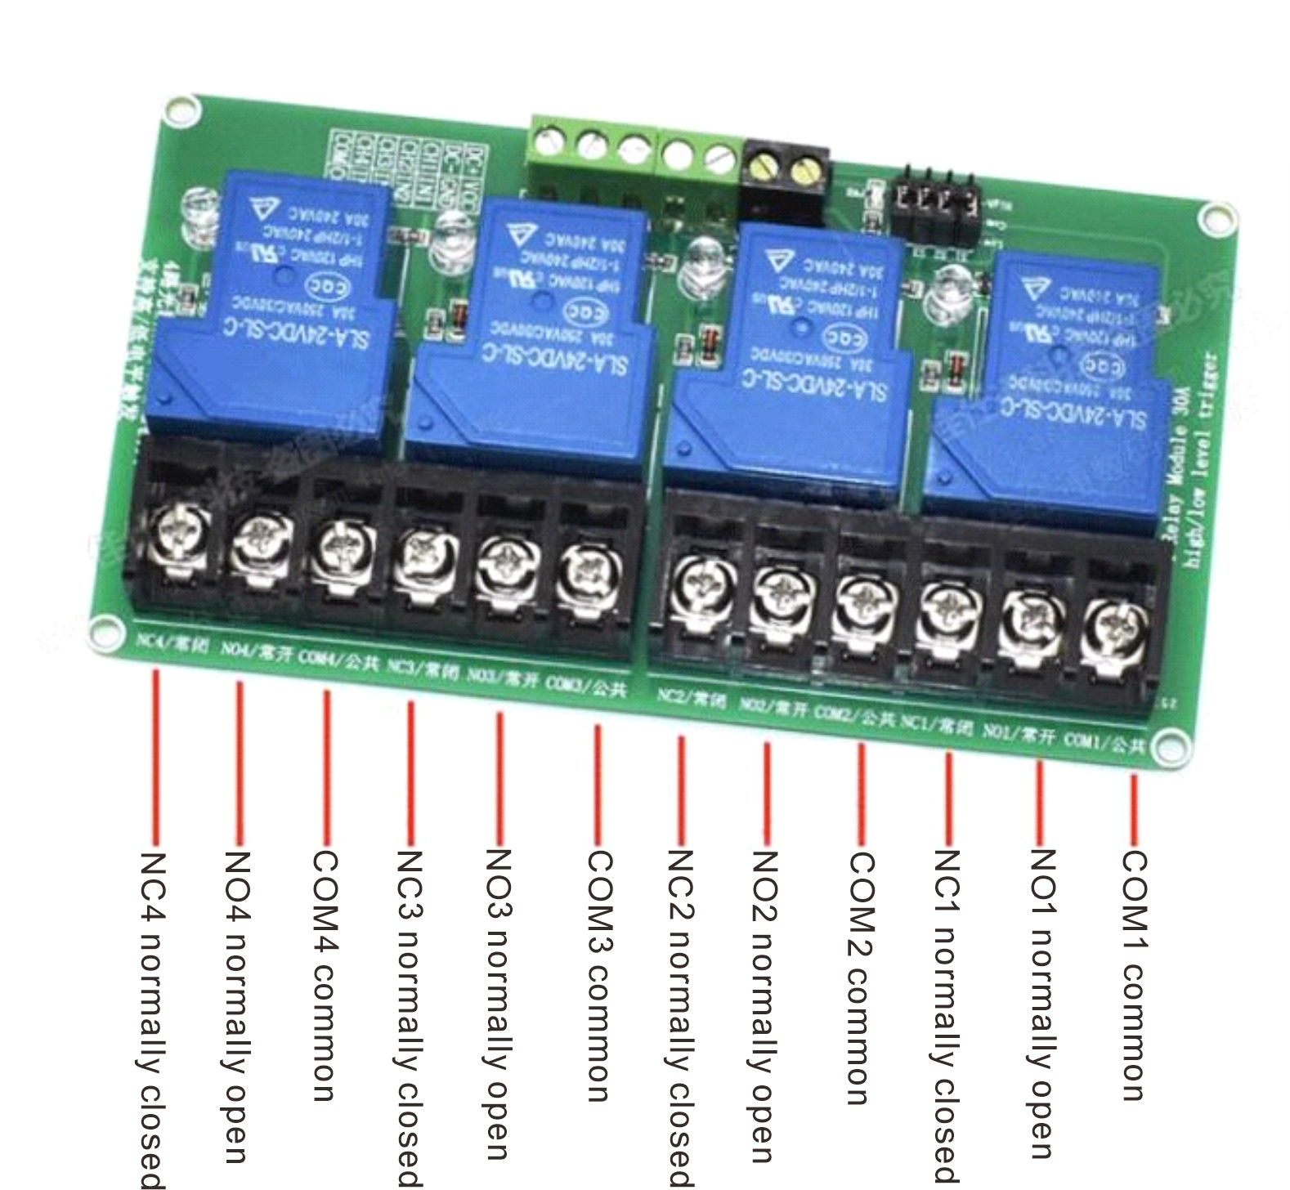
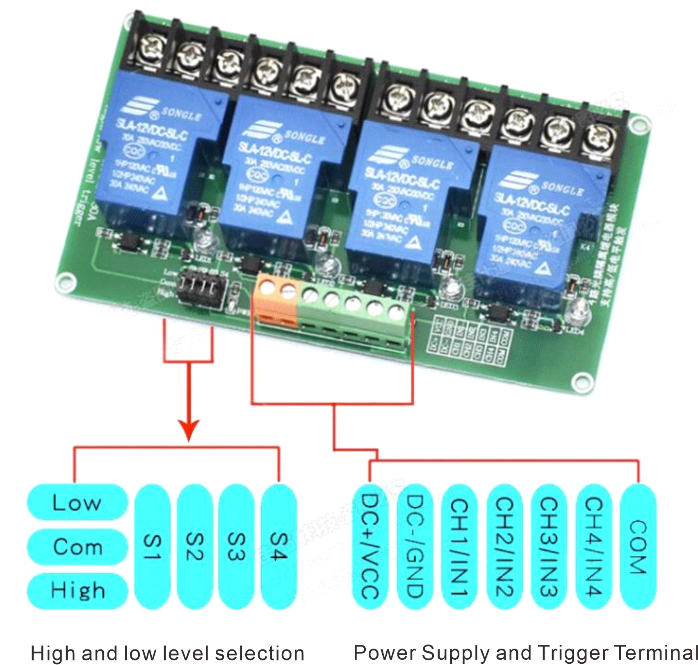
High and low level trigger selection terminals
1、S1-S4 is the high and low level triggering selection for relay 1 way-4 way in turn.
2、When com and 1ow are shorted, the corresponding relay is triggered at low level, and when com and hi qh are shorted, it is triggered at high level.

Usage
1, DC+(connect to DC positive pole) and DC-(connect to DC negative pole) are used to connect to the power supply of the module, the voltage is DC 12V.
2, IN terminal is the trigger terminal of the module, when there is a trigger signal, the output switch of the relay will be closed, and the load will be electrically energized.
3, The meaning of high level trigger and low level trigger:
High-level triggering: In industrial control, it is called PNP triggering, positive triggering, i.e., when the voltage between the trigger terminal and the negative pole of the power supply reaches the voltage of the triggering condition, the relay closes.
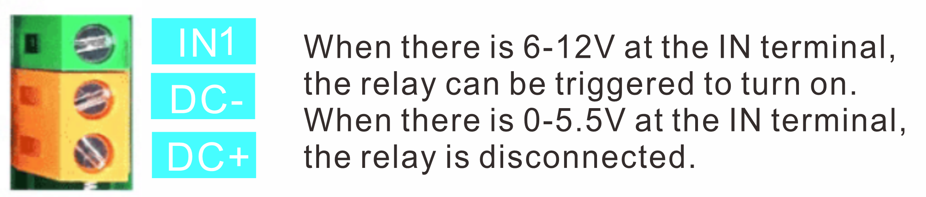
Low-level triggering: In industrial control, it is called NPN triggering, negative triggering, i.e., when the voltage between the trigger terminal and the negative terminal of the power supply is 0V or close to 0V, the relay closes.
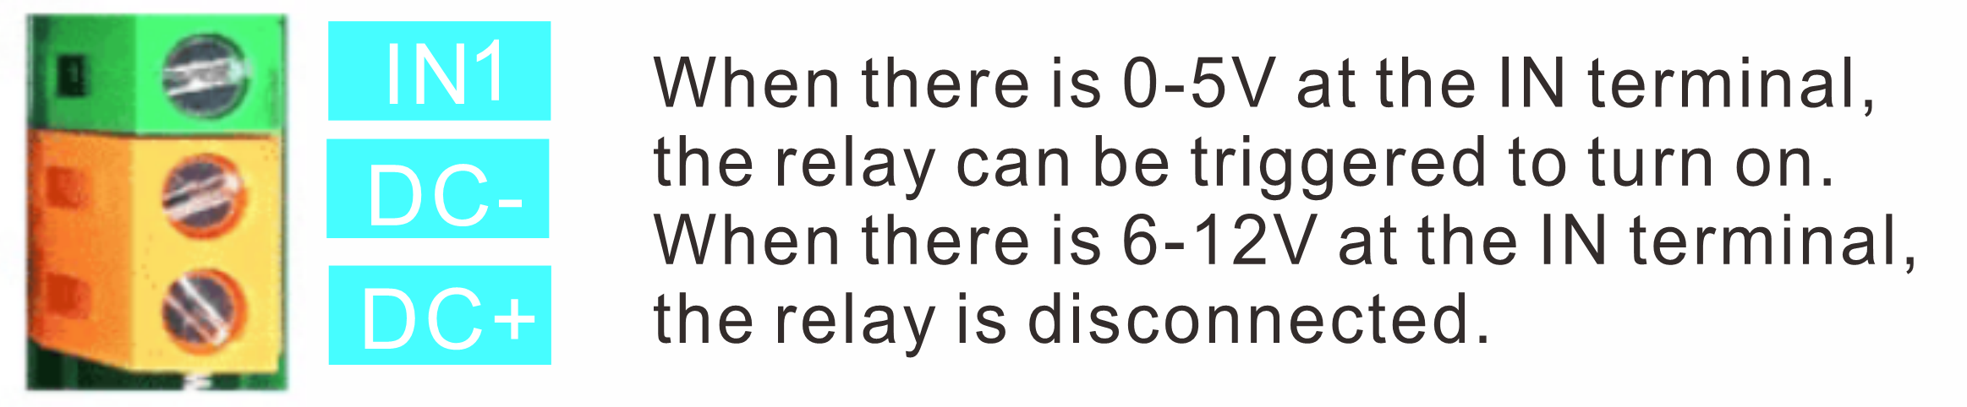

Relay Wiring Schematic

